LAB REPORT

CSE – 4508

Name : Abdullah

ID : 200041126

Lab Group : 1B

Submitted on : 24th August, 2023

Submitted to : MD. SHIHAB SHAHRIAR SIR

**Task 1**

In step 1, we need to make 2 separate tablespaces and generate tables in them. Later, we'll shift a table from one tablespace to the other.

**Initially, we must initiate a login using the SYS user credentials.**

conn sys as sysdba;

**Next, we'll generate 2 tablespaces using the command provided below.**



**Now we will create user in the created tablespace.**

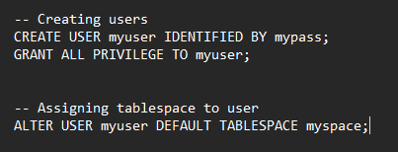

**Now we will create 4 tables and give them some random attributes.**

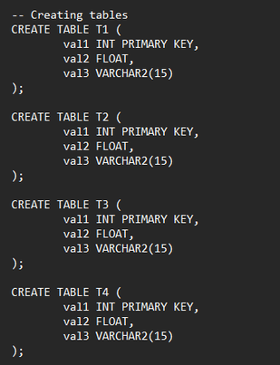





As we can see, we have successfully moved T4 to another created tablespace.

**Task 2**

For task 2, our objective is to establish a table using SQL. We'll then input data into this table. Following that, we'll execute SQL commands on the table to verify its functionality.

**At first we’ll create an Employee table**

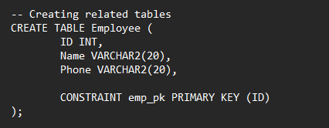

**Now, we will insert 12 data in the table**

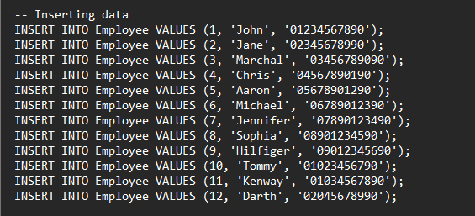

**This is our table –**

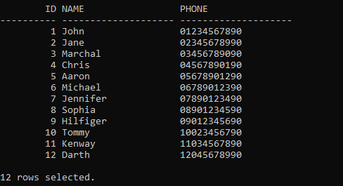

**Our next step involves crafting a query statement to retrieve employees whose phone numbers conclude with '990'. To accomplish this, we'll utilize the LIKE operator.**



**Result of the query is given below-**

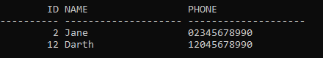

As you can see, we've successfully sorted out the numbers ending with '990'

**Task 3**

In task 3, we have to create 2 tables and test join operations among them.

**At first we’ll create 2 tables and insert data in the tables.**

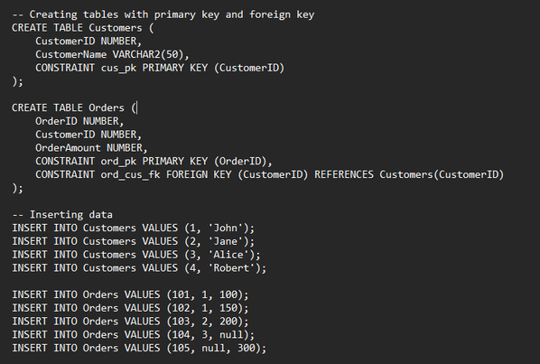

**First table:**

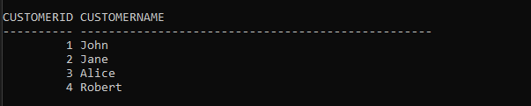

**Second table:**

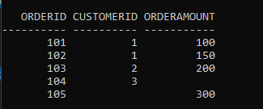

**Left outer join:**

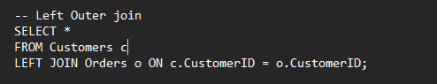

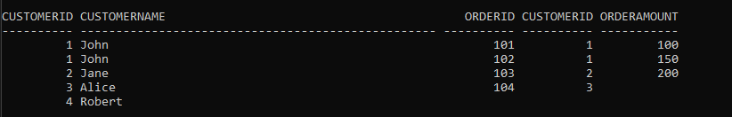

**Right outer join:**

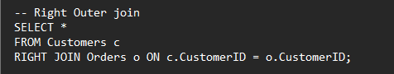

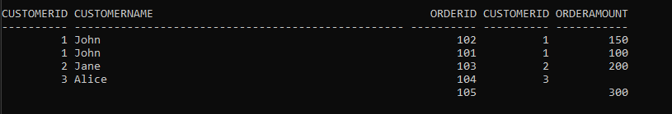

**Natural join:**

